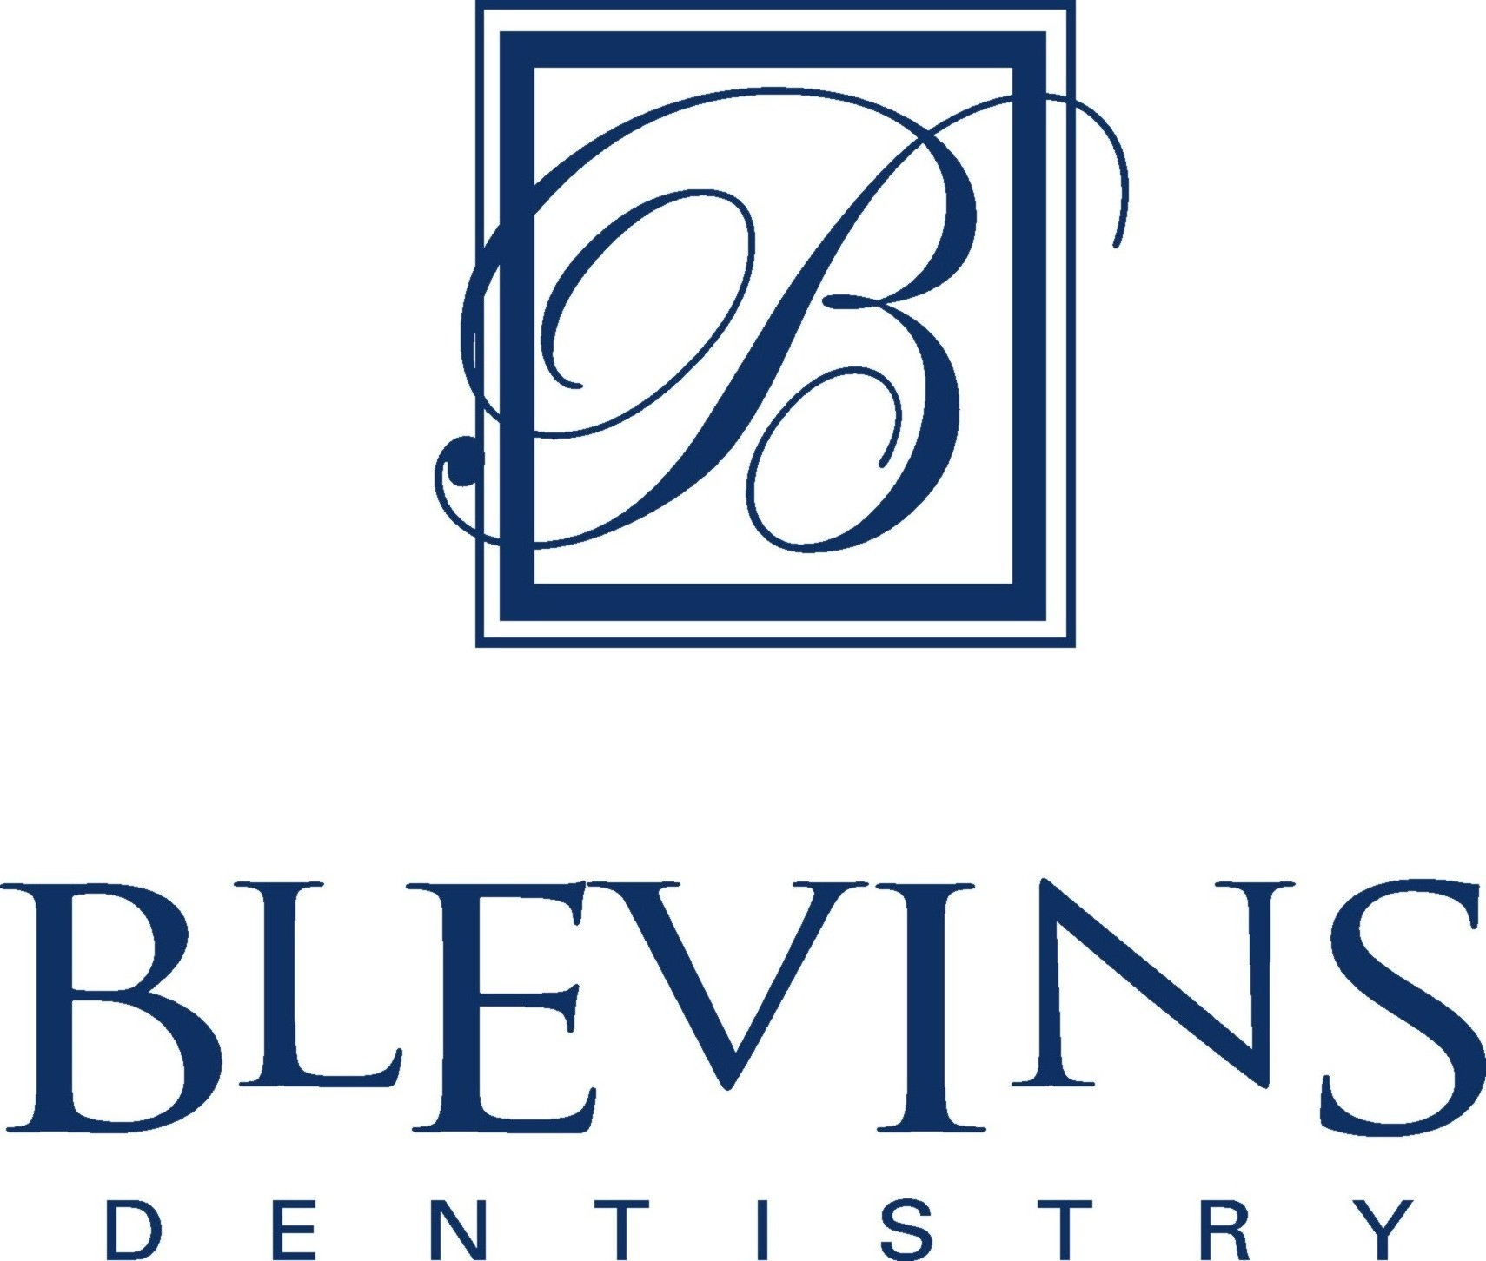

Patient Information
Patient Name: Date:
Last, First MI (Preferred Name)
Male Female / Married Single Child Widow Divorced
Email Address:_____________________________________________________________

Social Security #: ________________________________ Birth Date: _____________________

Phone (Home): (Work): _________________ Cell):___________ Best time to call:

Address: __________________________________________
Street Apartment City State Zip Code

How did you hear about our office?

Health Information
Yes No
( ) ( ) Are you having pain or discomfort at this time?
( ) ( ) Have you ever had a bad experience at a dental office?
( ) ( ) Have you been a patient in the hospital during the past 2 years?
( ) ( ) ***Are you allergic to (ie. Itching, rash, swelling of hands, feet or eyes) or
made sick by Penicillin, Aspirin, Codeine or any drugs or medicine? If yes, please circle the drug name. Other:________________________________________________________________________________________
( ) ( ) Have you ever had any excessive bleeding requiring special treatment?
( ) ( ) When you walk up stairs or take a walk, do you have to stop because of pain in your chest or shortness of breath?
( ) ( ) Do you use more than two pillows to sleep?
( ) ( ) WOMEN: Are you pregnant or think you may be? Are you nursing?
( ) ( ) Do you believe in the power of prayer and, through faith, the use of it in healing?

Have you ever had or have any of the following? Please Circle those that apply:

Heart Disease or Attack Kidney Trouble Rheumatism Drug Addiction
Angina Pectoris Ulcers Arthritis Hemophilia
High Blood Pressure Gastric Reflux Glaucoma Venereal Disease
Heart Murmur Bronchitis Pain in Jaw Joints (TMJ) Cold Sores
Mitral Valve Prolapse Cough Bruise Easily Genital Herpes
Rheumatic Fever Tuberculosis Alcohol Abuse Epilepsy or Seizures
Congenital Heart Defects Asthma Appetite Suppressants Fainting or Dizzy Spells
Heart Pacemaker Hay Fever AIDS/ HIV Nervousness
Artificial Heart Valve Sinus Trouble Hepatitis A Psychiatric Treatment
Artificial Joint (eg. knee or hip) Allergies/ Hives Hepatitis B Sickle Cell Disease
Radiation therapy Diabetes Hepatitis C Lupus
Stroke Thyroid Disease Liver Disease Blood Transfusion
Chemotherapy Anemia Yellow Jaundice Tobacco Use
Blood Thinners

Are You Presently Taking Or Have You Ever Taken Any Of the Following Drugs? Please Circle those that apply:
Birth Control Pills: Yes/No Steroids (Cortisone, Prednisone, etc) Yes/No
***Blood Thinners (Plavix, Coumadin): Yes/No Osteoporosis therapy (Fosamax): Yes/No

Please List All Medications You are Taking: ______________________________________________________________________________________________________________________________________________________________________________________________________

Dental Information
Date of Last Dental Visit: Name of Last Dentist: ______________Reason for this visit: _____________________

Do you have any of the following Dental Concerns? Please Circle those that apply:

Drink Well Water (No Fluoride) Crowded Teeth Jaw Joint Pain/Clicking(TMJ) Bleeding Gums
Yellow/Stained Teeth Fever Blisters/Cold sores Frequent Headaches Loose Teeth
Gaps Between Teeth Hot/Cold Sensitive Teeth Head, Neck or Jaw Injuries Clenching/Grinding Teeth

If you could change anything about your SMILE, what would you change? _____________________________________ ________________________________________________________________________________________________

To the best of my knowledge, all of the preceding answers and information provided are true and correct. If I ever have any change in my health, I will inform the doctors at the next appointment without fail.

X_________________________________________________________________ _________________ Date:________________________
Signature of patient, parent or guardian
Spouse or Responsible Party Information
The following is for: the patient's spouse the person responsible for payment

Name: _______________________Gender: Family Status: Date:

Social Security #: ________________________________Birth Date:

Phone (Home): ________________ (Work): ________________ Ext: ______ Best time to call:

Address:
Street Apartment #

City State Zip Code

Employment Information
The following is for: the patient the person responsible for payment

Employer Name: Occupation:

Address: ________________________________________________________________________________
Street City, State Zip Code Phone

Insurance Information

Name of Insured: _______________________________________________ Is insured a patient? Yes No
Last First MI
Insured's Birth Date: _________________ ID #: _____________________ Group #:

Insured's Address:
Street City State Zip Code
Insured's Employer Name:

Address:
Street City State Zip Code
Patient's relationship to insured: Self Spouse Child Other ___________________

Insurance Plan Name and Address:

Important Financial Information
Terms of Payment
Our primary mission at Blevins Dentistry is to deliver the finest, most cost effective dental care available. Your clear understanding of our financial policy is important to our professional relationship. We are available to answer any questions you may have.
Dental Insurance
As a courtesy, we will assign a staff person to assist you in attempting to verify your dental insurance, determine the limitations of your policy, identify your maximum dental insurance benefits, and assist you with filing the necessary forms so that you receive the benefits to which you are entitled. You should be aware that your dental insurance company does not guarantee payment over the telephone. We make no guarantee of any estimated coverage. Patients are responsible for all treatment fees regardless of insurance coverage.
Payment Options
- We accept Visa, MasterCard, Discover, and American Express, money orders, cash or a personal check.
- A convenient interest free payment plan (Care Credit) on amounts greater than $300.00.
- Pre-Approved monthly payment plan automatically drafted from your credit card or checking account.
Appointments
In order to allow the best possible care for you, we reserve a specific time just for you. We appreciate your promptness and your consideration in NOT changing your scheduled time. However, if you need to change your appointment 48 hours notice is expected. If three or more appointments are missed without notice, we will see you on an emergency basis until you have been able to locate another dental office, not to extend more than 30 days.
Patient Agreement
- I understand my insurance policy may deny or pay less than the actual bill for services.
- I authorize insurance payment directly to Blevins Dentistry.
- I authorize the release of necessary information to my insurance company to determine liability for payment and to obtain reimbursement for any claims.
- If my account is assigned to a collection agency or attorney, I will be responsible for all fees and court cost incurred.
- Any returned checks are subject to a $35.00 service fee and must be resolved before any future appointments can be arranged.
- An 18% interest will be applied to accounts over 90 days.

I have read the above conditions of treatment and payment and agree to their content.

_______________________________________ Date: _____________ Relationship to Patient:
Signature of patient, parent or guardian

Patient Consent for use and disclosure
Of protected health information
For the office of Doctor Todd S. Blevins

With my consent, the office of Blevins Dentistry may use and disclose protected health information about me to carry out treatment, payment, and healthcare operations (TPO). Please refer to the office of Blevins Dentistry Notice of Privacy Practices for a more complete description of such uses and disclosures.

I have the right to review the Notice of Privacy Practices prior to signing this consent. The office of Blevins Dentistry reserves the right to revise its Notice of Privacy Practices at anytime. A revised Notice of Privacy Practices may be obtained for forwarding a written request to Blevins Dentistry, Attn Heather Grant, Privacy officer at 622 South Main Street, Mullins, SC 29574.

Please check all that apply:

_____ With my consent, the office of Blevins Dentistry may call my home or other designated location and leave a message on voice mail or in person in reference to any items that assist the practice in carrying out TPO, such as appointment reminders, insurance items, and any call pertaining to my clinical care.

_____ With my consent, the office of Blevins Dentistry may mail to my home or other designated location items that assist the practice in carrying out TPO, such as appointment reminder cards and patient statements as long as they are marked personal and confidential.

I have the right to request that the office of Blevins Dentistry restricts how it uses or discloses my PHI to carry out TPO. However, the practice is not required to agree to my requested restrictions, but if it does, it is bound by this agreement.

Names and relationships of family or other individuals who you consent to know your PHI, (i.e. Husband, wife, mother, child, etc.).

Name Relationship Phone #

________________________________________________________________________________________

________________________________________________________________________________________

________________________________________________________________________________________

________________________________________________________________________________________

By signing this form, I am giving consent to the office of Blevins Dentistry to use and disclose my PHI to carry out TPO.

I may revoke my consent in writing except to the extent that the practice has already made disclosures in reliance upon my prior consent. If I do not sign this consent, the office of Blevins Dentistry may decline to provide treatment to me.

Signature pf patient or legal guardian ______________________________________________

Print name of patient
Or legal guardian ________________________________________ Date_____________________________

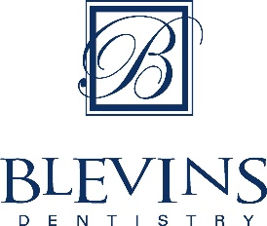

Patient Acknowledgement
Appointment Cancellation Guidelines

Dear Patient,

Blevins Dentistry has instituted Appointment Cancellation Guidelines.
A cancellation made with less than a 48-hour notice significantly limits our ability to make the appointment available for another patient in need.

To remain consistent with our mission, we have instituted the following guidelines:

1. Please give our office a 48-hour notice if you need to reschedule your
appointment. This will allow us the opportunity to provide care to another patient.

2. A “No-Show,” “No-Call,” or missed appointment without proper 48-hour notification may result in a broken appointment. Three broken appointments in an 18-month rolling period will result in a dismissal from the practice.

3. If you are 10 or more minutes late for your appointment, the appointment may be canceled and rescheduled.

4. As a courtesy, we send reminder texts for appointments 20 days before the appointment and send out text messages and phone calls starting 2 weeks before the appointment.

*Please note if a reminder call or message is not received, the cancellation policy remains in effect. The patient is responsible for keeping their file updated with the current phone number and mailing address.

5. Repeated missed appointments will result in termination of the physician/patient relationship.

If you have any questions regarding this policy, please let our staff know, and we will gladly clarify any questions you have.

I have read and understand the Appointment Cancellation Policy and acknowledge its terms. I also understand and agree that the clinic may amend such terms from time to time.

___________________________ ___________________________ ____________
Printed Name of Patient Signature of Patient Date

I, _____________________________________________, hereby grant and authorize Blevins Dentistry the right to take, edit, alter, copy, publish, distribute and make use of any and all pictures, video, or written/verbal statement taken of me to be used in and/or for legal promotional materials including, but not limited to, newsletters, flyers, posters, brochures, advertisements, fundraising letters, annual reports, press kits and submissions to journalists, websites, social networking sites and other print and digital communications, without payment or any other consideration. This authorization extends to all languages, media, formats and markets now known or hereafter devised. This authorization shall continue indefinitely, unless I otherwise revoke said authorization in writing.

I understand and agree that these materials shall become the property of Blevins Dentistry and will not be returned.

I hereby hold harmless and release Blevins Dentistry from all liability, petitions, and causes of action which I, my heirs, representative, executors, administrators, or any other persons may make while acting on my behalf or on behalf of my estate.

I warrant that I am of the age of consent (18 years or older) and that I am competent to contract in my own name. I have read this release before signing below and I fully understand the contents, meaning and impact of this release.

Print Name: ________________________________________________________________________

Signature: _________________________________________________________________________

Date: ________________________________________

Acknowledgement of Receipt of Notice of Privacy Practice
Blevins Dentistry
*You may refuse to sign this Acknowledgement*
I understand that, under the Health Insurance Portability and Accountability Act of 1996 (HIPPA), I have certain rights to privacy regarding my protected health information. I understand that this information can and will be used to:

- Conduct, plan, and direct my treatment and follow-up among the multiple healthcare providers who may be involved in that treatment directly and indirectly.
- Obtain payment from third-party payers.
- Conduct normal healthcare operations such as quality assessments and physician certifications.

I have received, read, and understand the Notice of Privacy Practices contain a more complete description of the uses and disclosures of my health information. I understand that this office has the right to change its Notice of Privacy Practices from time to time and that I may contact this office at any time to obtain a current copy of the Notice of Privacy Practices.

I understand that I may request in writing that you restrict how my private information is used or disclosed to carry out treatment, payment or health care operations. I also understand you are not required to agree to my requested restrictions, but if you do agree you are bound to abide by such restrictions.

Patient Name:_____________________________________________________

Signature of Patient or Legal Guardian: _________________________________

Date:_____________________

Blevins Dentistry
Notice of Privacy Practices

THIS NOTICE DESCRIBES HOW HEALTH INFORMATION ABOUT YOU MAY BE USED AND
DISCLOSED AND HOW YOU CAN GET ACCESS TO THIS INFORMATION. PLEASE REVIEW IT CAREFULLY.

We are required by law to maintain the privacy of protected health information, to provide individuals with notice of our legal duties and privacy practices with respect to protected health information, and to notify affected individuals following a breach of unsecured protected health information. We must follow the privacy practices that are described in this Notice while it is in effect. This Notice takes effect 11/01/2014, and will remain in effect until we replace it.
We reserve the right to change our privacy practices and the terms of this Notice at any time, provided such changes are permitted by applicable law, and to make new Notice provisions effective for all protected health information that we maintain. When we make a significant change in our privacy practices, we will change this Notice and post the new Notice clearly and prominently at our practice location, and we will provide copies of the new Notice upon request.
You may request a copy of our Notice at any time. For more information about our privacy practices, or for additional copies of this Notice, please contact us using the information listed at the end of this Notice.
____________________________________________________________

HOW WE MAY USE AND DISCLOSE HEALTH INFORMATION ABOUT YOU

We may use and disclose your health information for different purposes, including treatment, payment, and health care operations. For each of these categories, we have provided a description and an example. Some information, such as HIV-related information, genetic information, alcohol and/or substance abuse records, and mental health records may be entitled to special confidentiality protections under applicable state or federal law. We will abide by these special protections as they pertain to applicable cases involving these types of records.
Treatment. We may use and disclose your health information for your treatment. For example, we may disclose your health information to a specialist providing treatment to you.
Payment. We may use and disclose your health information to obtain reimbursement for the treatment and services you receive from us or another entity involved with your care. Payment activities include billing, collections, claims management, and determinations of eligibility and coverage to obtain payment from you, an insurance company, or another third party. For example, we may send claims to your dental health plan containing certain health information.
Healthcare Operations. We may use and disclose your health information in connection with our healthcare operations. For example, healthcare operations include quality assessment and improvement activities, conducting training programs, and licensing activities.
Individuals Involved in Your Care or Payment for Your Care. We may disclose your health information to your family or friends or any other individual identified by you when they are involved in your care or in the payment for your care. Additionally, we may disclose information about you to a patient representative. If a person has the authority by law to make health care decisions for you, we will treat that patient representative the same way we would treat you with respect to your health information.
Disaster Relief. We may use or disclose your health information to assist in disaster relief efforts.
Required by Law. We may use or disclose your health information when we are required to do so by law.
Public Health Activities. We may disclose your health information for public health activities, including disclosures to:
oPrevent or control disease, injury or disability;
oReport child abuse or neglect;
oReport reactions to medications or problems with products or devices;
oNotify a person of a recall, repair, or replacement of products or devices;
oNotify a person who may have been exposed to a disease or condition; or
oNotify the appropriate government authority if we believe a patient has been the victim of abuse, neglect, or domestic violence.
National Security. We may disclose to military authorities the health information of Armed Forces personnel under certain circumstances. We may disclose to authorized federal officials health information required for lawful intelligence, counterintelligence, and other national security activities. We may disclose to correctional institution or law enforcement official having lawful custody the protected health information of an inmate or patient.
Secretary of HHS. We will disclose your health information to the Secretary of the U.S. Department of Health and Human Services when required to investigate or determine compliance with HIPAA.
Worker’s Compensation. We may disclose your PHI to the extent authorized by and to the extent necessary to comply with laws relating to worker’s compensation or other similar programs established by law.
Law Enforcement. We may disclose your PHI for law enforcement purposes as permitted by HIPAA, as required by law, or in response to a subpoena or court order.
Health Oversight Activities. We may disclose your PHI to an oversight agency for activities authorized by law. These oversight activities include audits, investigations, inspections, and credentialing, as necessary for licensure and for the government to monitor the health care system, government programs, and compliance with civil rights laws.
Judicial and Administrative Proceedings. If you are involved in a lawsuit or a dispute, we may disclose your PHI in response to a court or administrative order. We may also disclose health information about you in response to a subpoena, discovery request, or other lawful process instituted by someone else involved in the dispute, but only if efforts have been made, either by the requesting party or us, to tell you about the request or to obtain an order protecting the information requested.
Research. We may disclose your PHI to researchers when their research has been approved by an institutional review board or privacy board that has reviewed the research proposal and established protocols to ensure the privacy of your information.
Coroners, Medical Examiners, and Funeral Directors. We may release your PHI to a coroner or medical examiner. This may be necessary, for example, to identify a deceased person or determine the cause of death. We may also disclose PHI to funeral directors consistent with applicable law to enable them to carry out their duties.
Fundraising. We may contact you to provide you with information about our sponsored activities, including fundraising programs, as permitted by applicable law. If you do not wish to receive such information from us, you may opt out of receiving the communications.
Other Uses and Disclosures of PHI
Your authorization is required, with a few exceptions, for disclosure of psychotherapy notes, use or disclosure of PHI for marketing, and for the sale of PHI. We will also obtain your written authorization before using or disclosing your PHI for purposes other than those provided for in this Notice (or as otherwise permitted or required by law). You may revoke an authorization in writing at any time. Upon receipt of the written revocation, we will stop using or disclosing your PHI, except to the extent that we have already taken action in reliance on the authorization.
Your Health Information Rights
Access. You have the right to look at or get copies of your health information, with limited exceptions. You must make the request in writing. You may obtain a form to request access by using the contact information listed at the end of this Notice. You may also request access by sending us a letter to the address at the end of this Notice. If you request information that we maintain on paper, we may provide photocopies. If you request information that we maintain electronically, you have the right to an electronic copy. We will use the form and format you request if readily producible. We will charge you a reasonable cost-based fee for the cost of supplies and labor of copying, and for postage if you want copies mailed to you. Contact us using the information listed at the end of this Notice for an explanation of our fee structure.
If you are denied a request for access, you have the right to have the denial reviewed in accordance with the requirements of applicable law.
Disclosure Accounting. With the exception of certain disclosures, you have the right to receive an accounting of disclosures of your health information in accordance with applicable laws and regulations. To request an accounting of disclosures of your health information, you must submit your request in writing to the Privacy Official. If you request this accounting more than once in a 12-month period, we may charge you a reasonable, cost-based fee for responding to the additional requests.
Right to Request a Restriction. You have the right to request additional restrictions on our use or disclosure of your PHI by submitting a written request to the Privacy Official. Your written request must include (1) what information you want to limit, (2) whether you want to limit our use, disclosure or both, and (3) to whom you want the limits to apply. We are not required to agree to your request except in the case where the disclosure is to a health plan for purposes of carrying out payment or health care operations, and the information pertains solely to a health care item or service for which you, or a person on your behalf (other than the health plan), has paid our practice in full.
Alternative Communication. You have the right to request that we communicate with you about your health information by alternative means or at alternative locations. You must make your request in writing. Your request must specify the alternative means or location, and provide satisfactory explanation of how payments will be handled under the alternative means or location you request. We will accommodate all reasonable requests. However, if we are unable to contact you using the ways or locations you have requested we may contact you using the information we have.
Amendment. You have the right to request that we amend your health information. Your request must be in writing, and it must explain why the information should be amended. We may deny your request under certain circumstances. If we agree to your request, we will amend your record(s) and notify you of such. If we deny your request for an amendment, we will provide you with a written explanation of why we denied it and explain your rights.
Right to Notification of a Breach. You will receive notifications of breaches of your unsecured protected health information as required by law.
Electronic Notice. You may receive a paper copy of this Notice upon request, even if you have agreed to receive this Notice electronically on our Web site or by electronic mail (e-mail).
Questions and Complaints
If you want more information about our privacy practices or have questions or concerns, please contact us.
If you are concerned that we may have violated your privacy rights, or if you disagree with a decision we made about access to your health information or in response to a request you made to amend or restrict the use or disclosure of your health information or to have us communicate with you by alternative means or at alternative locations, you may complain to us using the contact information listed at the end of this Notice. You also may submit a written complaint to the U.S. Department of Health and Human Services. We will provide you with the address to file your complaint with the U.S. Department of Health and Human Services upon request.

We support your right to the privacy of your health information. We will not retaliate in any way if you choose to file a complaint with us or with the U.S. Department of Health and Human Services.

Our Privacy Official

Telephone: 843 464 6162 Fax: 843 464 8235

Address: 622 S Main Street Mullins SC 29574

E-mail: BlevinsDentistry@aol.com

Reproduction of this material by dentists and their staff is permitted. Any other use, duplication or distribution by any other party requires the prior written approval of the American Dental Association. This material is educational only, does not constitute legal advice, and covers only federal, not state, law. Changes in applicable laws or regulations may require revision. Dentists should contact their personal attorneys for legal advice pertaining to HIPAA compliance, the HITECH Act, and the U.S. Department of Health and Human Services rules and regulations.

© 2010, 2013 American Dental Association. All Rights Reserved.

